  - The Evolution of the World’s Production Fragmentation: 2000 – 2014, a network analysis

Susana Vieira*
ISEG-Lisbon School of Economics and Management, Universidade de Lisboa
*corresponding author (susana.vieira92@gmail.com)

Renato G. Flôres Jr.
FGV IIU and FGV EPGE, Fundação Getúlio Vargas

Maria Paula Fontoura
ISEG-Lisbon School of Economics and Management and UECE-Research Unit on Complexity and Economics, Universidade de Lisboa

Abstract♠

The present work belongs to a stream of studies transforming Input Output (IO) matrices into several weighted and directed networks accounting for different values of supply-use flows between sectors and, if regional, countries. Traditional trade statistics do not fully capture the fragmentation of international production, being responsible for double counting in import and export data. To fill this gap, a handful of internationally linked IO datasets have emerged. This work makes use of the network analysis method to characterize the evolution of the world’s trade in value added between 2000 and 2014. It uses data from the latest release of the WIOD database to build trade in value added indicators in a country basis, to be used for graph visualization and the computation and analysis of network-based measures. In contrast with previous studies, it includes more recent time moments, consolidating some of their conclusions. Only a small number of countries occupy central positions in the international production chains, be it in the number of partners, in the value of bilateral supply and/or use relationships and in the connections with other central partners: at the end of the day, concentration seems to be the name of the game. Without Germany, Europe loses its pumping engine; the same for Asia without China and, in 2014, for the whole world, without the US. Will China eventually either absorb or dominate the other hubs, becoming the new central node of the World Trade Network?

♠ Financial support from FCT (Fundação para a Ciência e a Tecnologia, Portugal) under the Strategic Project UID/ECO/00436/2019 is acknowledged.

Keywords: Global Value Chains; Input-Output Matrix; Trade in Value Added; Network Analysis; Graphs; Node Degree; Node Strength; Eigenvector Centrality.

JEL: F01; F23
1. Introduction

Global Value Chains (GVCs) translate the principle of labour division in an international or global scale. The idea behind the concept, the breakup of production in several stages, one at least taking place in a different country, has gained steam in the last decades due to an ever-increasing fragmentation of production stirred by the advances in transportation, Information and Communication Technologies and in services in general. Likewise, multinationals play a vital role in GVCs by outsourcing their production to third countries.
The literature on GVCs is already extensive and verses upon two different lines: (i) the impacts for GVC-participating countries and (ii) the appropriate measurement of GVC participation. The former includes a vast range of case studies and generic empirical models that cover from the economic spillovers of GVC participation, either technological (Brach and Kappel, 2009) or in productivity (Baldwin and Yan, 2014) and knowledge diffusion (Saliola and Zanfei, 2009) to foreign direct investment (Martinez-Galán and Fontoura, 2018). A wide range of references focuses on the impacts of GVC participation in development, especially for countries in the latter stages of development. The argument is usually that, before, developing countries had to build a whole production chain by themselves, whereas now they can specialize in a particular stage of the manufacturing process (Taglioni and Winkler, 2016). The latter –more methodological- is based on the premise that, by not accounting for the import content of a country’s exports, traditional trade statistics do not fully capture the fragmentation of international production and are responsible for double-counting in import and export data. To fill this gap, a handful of internationally linked Input-Ouput (IO) datasets have emerged. Their focus is in supply-use relationships, highlighting their function as either production intermediates or final demand rather than simply working with a commodity or service classification.
The World Input-Ouput Database (WIOD) is often used by researchers; its second, 2016 release included data for 43 countries and 56 sectors, an enhancement from its first one (2013), with data for 40 countries and 35 sectors. It covers 85% of the world trade and allows for the study of the impacts of the international fragmentation of production in environmental and socio-economic issues. As described by Timmer et al. (2016), national IO tables are combined with bilateral international trade statistics to disagreggate the imports by country of origin and use category, to generate an international supply and use table. It is important to note that the methodology produces IO tables that are estimates and not a precise measurement.
Since Hummels et al. (2001)’s seminal attempt that introduced the concept of Vertical Specialization (VS) to the emergence of trade in value added (TiVA), to Koopman et al. (2011 and 2014), who attempted to refine and bring together previous measures, several authors, departing from IO tables, have provided empirical evidence about the changes in international trade due to the international interdependences in production processes.
In the same way as the research on GVCs, use of the network analysis method for input-output trade data is recent and will certainly experience further developments. Authors reinforce its potentialities to understand trade in value added. Some argue that the complexity of the measures in network theory and the ability to build models that incorporate these features are powerful tools to understand GVCs, Amador and Cabral 2015; others that network analysis enables to grasp the heterogeneity of different actors and trade links in GVCs, Santoni and Taglioni (2015), and that network-based measures can be correlated to external factors such as the presence of multinational groups, Altomonte et al. (2015). It is an intuitive mode of representing trade in value added, as IO tables are themselves weighted and directed networks.
The present work applies the network analysis method to characterize the evolution of the world’s TiVA between 2000 and 2014. It uses the latest release of the WIOD to build trade in value added country data, suitable for graph visualisation and the computation and analysis of network based-measures.
The paper organizes as follows. Section 2 briefly explains the methodology used for the graph visualisation and analysis, as Node and Eigenvector Centrality, and the use of filters for unveiling the backbone of the flows. Section 3 presents a rather comprehensive review of the available literature, highlighting the advantages of the network analysis method for a better understanding of the nature and topology of world trade and production networks. Section 4 describes the two basic graphs and related descriptive statistics, to analyse the world trade in value added in 2000 and in 2014. In section 5, we identify patterns by computing several parameters and indicators. The most robust flows, making for the roots of the GVCs dynamics, are also uncovered. Section 6 concludes.

2. Networks of trade in value added – a brief comment on the tools and statistics used.

Graph theory is a widely recognized field in mathematics; the subsequent network analysis was developed in different areas and adopted as a methodology by social sciences due to its potentialities in assessing social phenomena. In the field of economics, several international economists –e.g. Benedictis and Tajoli (2011)- and econophysicists –e.g. Kali and Reyes (2007), Serrano and Boguñá (2003) and Serrano et al. (2007)- have advocated the potential of the social network analysis methodology to an insightful visualisation of world trade.
Indeed, according to Benedictis and Tajoli (2011), trade flows between countries can be naturally represented by a straight line (trade flows) connecting two points (countries): a network’s structure and/or visualisation consists of a set of points, called nodes or vertices with connections between them called edges or links. It is possible to add complexity to the nodes or edges by weighting them. A directed network fully captures the direction of flows, while nodes can be weighted to highlight the importance of specific countries, in line with what Serrano and Boguñá (2003) call a perfect example of a real-world network that illustrates competitive relationships. All this plays an important role in the analysis of the so-called World Trade Network (WTN), International Trade Network (ITN) or World Trade Web (WTW). It is also intuitive, as the amount of trade between a pair of countries (usually measured in monetary values of imports and/or exports) is treated as the link weight (Bhattacharya et al., 2008), thus reflecting the different magnitudes of bilateral trade relationships.
Based on the idea that an IO matrix can be associated to several weighted directed networks -depending on the aggregations used, a relatively recent body of literature has applied network analysis in the study of GVCs, with the purpose of identifying a country or a country-sector position in the world production networks, or to explore interdependencies within them.
The computation of network-based measures of connectivity and centrality is crucial to the above-mentioned purposes as they allow the identification of connection partners and of key hubs inside the network. There is a broad range of such measures in network analysis whose formulas vary in presence of a weighted/unweighted network.
Supposing a TiVA network of countries, connectedness includes Node Degree (ND) –the number of a country’s trade partners- and Node Strength (NS) -the value or intensity of a country’s trade relationship. In directed networks these measures divide into indegree and outdegree. NS and ND are often referred to as Node Centrality in the literature, though centrality includes a wider range of measures depending whether only direct links are counted (closeness centrality, between-ess centrality) or also the indirect links are considered (e.g. eigenvector centrality, as explained below).
Two main fields of research generate methods for the analysis of world’s commerce, one emerging from political sciences and the other, initiated in the 2000s, known as econophysics. Essentially, the former takes international trade as a starting point to the world system theory based on the structure of the WTN and analyses either an individual country’s or a group of countries’ position in world’s trade; the latter is more focused on the topological properties of the WTN.
In the networks built in this paper, nodes represent countries and are weighted by their total trade in value-added (TTVA), bigger diameters representing higher TTVA values. The edges or links are weighted according to the size of the bilateral value-added trade flows, with higher thickness accounting for higher flows; they are coloured accordingly, with dark grey indicating the 10% highest flows. With the nodes weighted by TTVA and the edges connecting to the suppliers and users of value added it is possible to break out a country TTVA, getting a sense of the world suppliers and users and, more specifically, how domestic and foreign value-added (DVA and FVA, respectively) split in the world’s economy.
As the networks are directed, they allow the visualisation of the trajectory of bilateral value added flows (with arrows pointing to the destination, user country). Two important concepts are associated with this visualisation: the indegree, referring to the number of incoming edges (user country), and the outdegree, referring to the number of outgoing edges (supplier country). Weighted networks permit the analysis of node strength which, for directed networks, also splits into indegree and outdegree strength.
A few fundamental identities apply in our weighted and directed networks, like: NS is equal to a countries’ TTVA; indegree and outdegree strength are equal to a countries’ FVA and DVA, respectively.
Standard connectdeness and centrality measures are used in the analyses to follow. The most important centrality parameter involving indirect links is the eigenvector index. NS and ND, also considered centrality measures, only capture direct links and neglect indirect linkages. In order to fully understand a country’s role in the users and suppliers’ network, Eigenvector Centrality is a finer node-related measure. The rationale behind it is that connections to high-scoring nodes contribute to the score of the node in question. The measure thus contemplates indirect linkages, differing from other centrality indexes, as closeness or betweeness centrality, which disregard the neighbours’ score. Based on Bonacich (1987), the Eigenvector Centrality Index for the nodes in a network is usually calculated by Tang’s et al. (2015) formula.
Kali and Reyes (2007) stress another feature of network visualisation: the possibility of adding a threshold that not only allows for a better visualisation but also deeper conclusions about the backbone structure of world’s trade. To arrive at a basic structure for the WTN, links or flows in our networks were progressively eliminated according to a sequence of thresholds. This eventually produced a new set of highly informative graphs, from the same original ones, clearly showing the backbone of the world’s GVC mesh.

3. World Trade Networks – Analysis with traditional trade statistics and IO matrices.
Network analysis provides a relational view of the world’s trade rather than focus on an individual country’s performance. This contrasts with other traditional approaches such as gravity models, measures of comparative advantage and constant market share (Reyes et al., 2008), as it permits the visualisation of the complete structure of the world’s trade, and the network-based measures are powerful tools for the examination of trade flows’ properties and patterns.
Several issues associated with world’s economic integration have thus been analysed under the scope of network analysis. They range from the duality between Globalisation and Regionalisation (Kim and Shin, 2002), to world’s system division into a core-periphery duality studied with total (Snyder and Kick, 1979) or disaggregated international trade data (Smith and White, 1992). More recently, Benedictis and Tajoli (2011) employed network-based measures to address some issues in the trade policy debate: (i) the role of WTO in international trade, (ii) the existence of regional blocs in a globalized world and (iii) the dimensions of the extensive and intensive margins of trade. Actually, network analysis has enabled authors to reach different but important conclusions not only about the configuration of international trade, but also about wider issues concerning globalization.
In a seminal work, Snyder and Kick (1979) studied the world’s system theory by presenting a bloc-model network analysis for trade flows, circa 1965. Their analysis corroborated the theory by finding the presence of three different positions: Core, Semi periphery and Periphery. In terms of interactions, they found that every bloc has more trade linkages with the core than with any other. Later, Smith and White (2002) and Mahutga (2006) elaborated on this analysis including several time points and trade data aggregated in 15 types of commodities. From the disaggregation of trade data, Smith and White (2002) learned that manufacturing flows tend to occur from the centre to the periphery, whereas the inverse is true for agricultural products. In 2006, using trade data from the year 2000, Mahutga started to notice the rise of labour-intensive manufacturing in non-core zones such as Eastern Europe and in the so-called Asian tigers.
Reyes et al. (2008) aggregated trade data into four types: raw materials, intermediate, final and capital goods. Their network analysis aimed to enrich the exploratory literature about the rise of the BRIICS performance in the world system. Their centrality index suggested that the BRIICS (with the exception of Indonesia) are highly integrated in the WTN, even though the increase in their level of integration bears some differences among countries and product types.
Papers with a more exploratory character of the WTN properties have also reached important conclusions upon the best way of representing world trade in a network. Focus here shifts from the hierarchical position of countries within the WTN to the correlation between network-based measures to explore the properties of world trade.
Garlaschelli and Loffredo (2005) broke from previous studies focusing on a single or a few snapshots of the WTW and addressed it as a directed and evolving network from 1950 to1996. They found a decreasing trend between clustering coefficient and degree distribution signalled that partners of well-connected countries are less interconnected than partners of poorly connected countries. Fagiolo et al. (2008) challenged the topological properties of the WTW found in previous studies, including those by Garlaschelli and Loffredo (2005). They argued that the binary approach to the world trade network is not accurate as it treats every trade link as homogeneous, regardless of their actual value. They used weighted approach instead and concluded that well-connected countries are associated with higher clustering coefficients, which confirms the existence of trade clubs.
Serrano et al. (2007) built and analysed the world network of trading imbalances. In their network, the links represented the difference between exports and imports and were weighted by the magnitude of that difference. By applying a local heterogeneity analysis, the authors obtained the backbone of the WTN for 1960 and 2000, which corresponds to the links that carry the biggest proportion of a country’s inflow or outflow. Furthermore, the authors have taken a first step into the study of GVCs using traditional trade data, by considering that producer and consumer countries do not completely absorb the incoming or outcoming fluxes.
The literature applying network analysis to GVCs has addressed, till now, two major issues: (i) the analysis of countries’ and country-sector’s positioning and (ii) propagation of economic shocks along the world production network. The former applies network-based measures to derive its conclusions and the latter complements the study of these measures by correlating them with external factors that enable conclusions about which countries or sectors are most vulnerable to the persistence and/or propagation of economic shocks.
Amador and Cabral (2015), using WIOD data for 40 countries, employed basic network visualization tools to describe the characteristics of GVCs, in 1995 and 2011, that represented bilateral flows of FVA. They focused mainly in individual countries’ centrality, finding that bigger countries tend to have higher nodes and appear “in the centre of the network” as suppliers of value added. In addition, the authors built the world’s networks for manufacturing and services to conclude that the density of the manufacturing one was much higher than that of the services network, meaning that nations are more interconnected in the trade of manufacturing goods.
Focusing on country-sectors rather than solely on individual countries, Santoni and Taglioni (2015) computed the network of intra-sectoral trade for the automotive sector (buyers and suppliers) and the network for trade in value added for country-sectors in 2009. They concluded that the increasing centrality of emerging countries is most prominent in the demand side than in the supply side in technology intensive GVCs, and that US industries are still at the core of the network of global trade, alongside German business services, Chinese retail and Russian mining.
Cerina et al. (2015) configure the world’s production system as a network where the nodes are the different industries in different countries for 1995 and 2011, including self-loops that represent intra-industry national trade. They found that a great part of the economic transactions still occurs within national borders and contains many self-loops (high number of industries self-feeding themselves). At the regional level, they employ a community-detection analysis that compares their network with a null-model graph that assumes that a random graph is not expected to have a community structure. They concluded that “global production” is still mostly national or, at best, regional.
Criscuolo and Timmis (2018) applied a variant of the Bonacich-Katz eigenvector centrality to OECD ICIO data, obtaining metrics based on forward and backward linkages. They found that there have been profound changes in the structure of GVCs along 1995-2011; whilst some activities remained clustered around the same key hubs as in the start of the period, for others there have been dramatic relocations (e.g. manufacturing of computer and electronic sector). At the country-level, evolution took place around three main regions: Factory Europe, Factory Asia and Factory America. The evolution is significant, with the consolidation of Germany and the US as central hubs in their respective regions and the diminishing role of Japan as a key hub in Asia, where China now plays a central role.
Carvalho (2014) argued that the structure of production networks is crucial in determining whether and how microeconomic shocks (affecting only a particular firm or technology along the chain) propagate through the economy as such networks expose critical nodes in the chains. This is particularly evident when a small number of central hubs supply inputs to many different firms or sectors. Using also network analysis to assess propagation of economic shocks along production networks, Blochl et al. (2011) computed two measures of centrality: random walk and counting-betweeness centrality. The first one is important to reveal the vertices instantaneously affected by a shock and the second one locates where a shock carries on longer.
Taking on the poor economic theory character of the previous studies, Contreras and Fagiolo (2014) proposed a diffusion model that took into consideration the origin of the shock, its impact on IO linkages and the possibility that, after the shock hits a certain sector, production levels adjust.

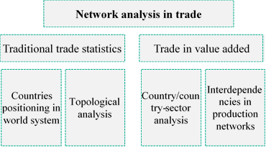
Figure I: Network analysis in trade: the four different modalities.

Figure I summarises the main streams of literature employing network analysis to trade by segmenting it in traditional trade statistics and in TiVA ones. There exist some similarities in the conclusions of the studies, as the network-based measures are essentially the same. Moreover, some authors have taken small steps to the study of GVCs by decomposing traditional trade statistics into several commodity types, having reached different conclusions for different sectors.
However, differences are more striking when one realises that a (standard) trade network is not a production network, what influences the type of issues studied by each subset. From the perspective of traditional trade statistics networks, focus is on the inequality provoked by the asymmetries in world trade whereas in those of trade in value added, authors have studied the propagation of economic shocks by assuming the interdependencies among countries and sectors in the network. The literature using traditional trade statistics emphasizes much more the rise of emerging economies; that of trade in value added networks also acknowledges it, but alerts that their centrality varies according to the sector in consideration.

4. The world users and suppliers’ network, 2000 and 2014.

We combine TTVA per country with computed bilateral TiVA flows to build and visualize the world’s users and suppliers network. Two elements are fundamental in the network: the nodes, the 43 countries available in the WIOD, and the edges, the bilateral trade in value added flows amongst the nodes (for 2000 and 2014). Even though the WIOD includes the RoW, it has been excluded from the network and further calculations because, as an aggregate of economies, it would profoundly influence the nodes and edges weights, since it embodies a disproportionate number of economies for which TiVA data is not specified.
Figures II and III represent the world’s suppliers and users network for 2000 and 2014, respectively, with countries roughly displayed according to their geographic location. To facilitate visualisation without blurring the most relevant flows and not excluding any of the 43 countries, a threshold has been defined: only those flows accounting for at least 1% of user or supplier countries’ exports appear. Analyses and calculations will be conducted using this resulting graph.
From the figures one can see that the number of flows has increased over time, meaning that the network density has increased. Density is the ratio between the total number of links and the maximum possible one, ranging from 0 to 1. In both figures, were it not for the threshold, the networks would have a total density of 1, as in the original IO tables all countries have flows with each other. As the focus here is only on the most relevant flows, the density goes from 0,39, in 2000, to 0,40 in 2014.
A broad pattern is common to both figures: three clear groups, North America, a EU cluster and a more sparse Asian one, with Indonesia and India further apart, and four “individualities” or “oddities”, Brazil, Turkey, Russia and Australia. In the denser but also more concentrated 2014 network, Turkey gets closer to the EU and Australia to Asia. The Asian cluster becomes somewhat tighter, as India and Indonesia move closer to the other countries in it.
Table I confirms that flows at least 1% of the supplier or users TTVA have slightly grown from 2000 to 2014; this is also true for the total TTVA which has more than trebled. Distributionwise, both mean and median values are low and much closer to the lowest bilateral flow; the distribution of bilateral TiVA flows is left-skewed, as shown by a larger mean value than the median. The left bias of the distribution is further corroborated by the trade flows

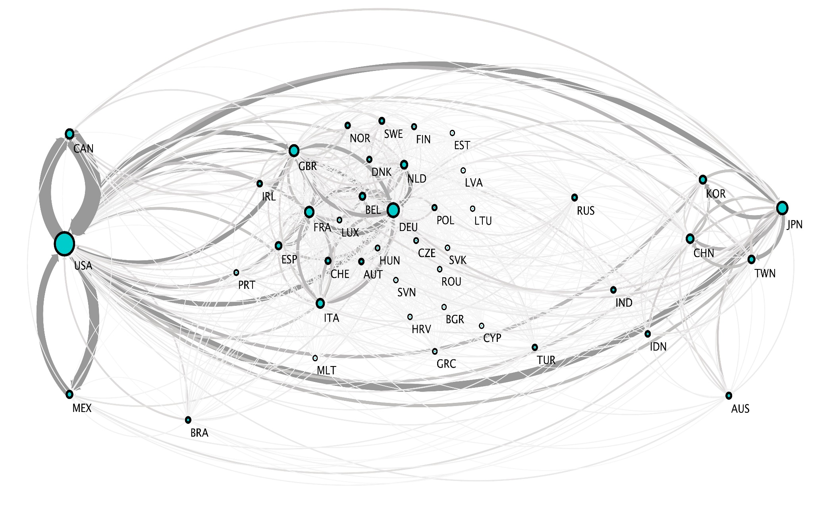

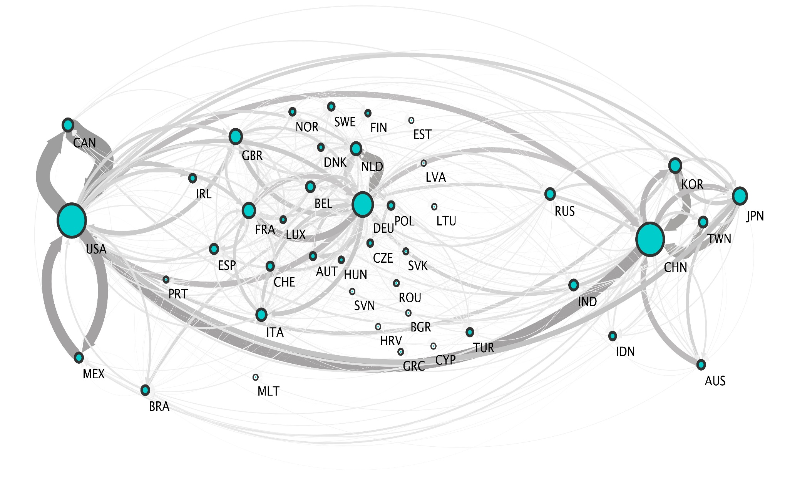

Table I: Descriptive statistics and flow intensities

 | 2000 | 2014
Total No of Countries | 43 | 43
Total No of flows | 713 | 730
Total value of TTVA (Billion US dollars) | 2408,7 | 6790,7
Lowest bilateral flow (Billion US dollars) | 2,1 | 7,0
Highest bilateral trade flow (Billion US dollars) | 874,1 | 1885,2
Average TTVA (Billion US dollars) | 3,4 | 9,3
Median TTVA (Billion US dollars) | 1,0 | 3,4
No of countries making up 50% of TTVA | 17 | 23
No of flows making up 50% of TTVA | 45 | 57
No of countries making up 90% of TTVA | 34 | 35
No of flows making up 90% of TTVA | 260 | 316
% of TTVA belonging to the top 10% flows | 61,7% | 56,3%
% of TTVA belonging to the top 10 flows | 23,2% | 19,5%

Source: Author’s calculations based on WIOD IO data for 2000 and 2014

intensities’ displayed in Table I, where a small number of flows accounts for most of total TTVA flows. The results differ however slightly from 2000 and 2014. In 2000, only 17 countries made up 50% of the wordl’s TTVA and, in 2014, more than half of the countries (23) under analysis accounted for half of the world TTVA. Over time, there is an increase in participation in production networks. In spite of this, a small number of countries still does not have a substantial participation in the global production networks, as 34 and 35, out of the 43 countries at stake, made for 90% of the TTVA in 2000 and 2014, respectively.

5. Network Analysis.

Visualisation and descriptive statistics

From Figure II, in 2000, the bilateral flow with the highest value was by far the one from Canada to the US, with the opposite flow in the second position. “Factory America” is clearly dominated by the US, which is not only the country with the biggest node, but also accounts for the thickest intra and inter regional flows; most of the flows to and from the US are also colored with dark grey, which means that in 2000 they belonged either to the 10% highest flows or to the top 10 highest ones.
Other noticeable flows are those between the US and Japan. Japan was, in 2000, the country with the highest TTVA in “Factory Asia”, as well as the centre of intra regional flows. However, Japan’s centrality within Factory Asia was not as visually evident as the US one in Factory America, other Asian countries such as China, South Korea and Taiwan already exhibited strong positions within the region. The thickest intra-regional flows were the bilateral ones between South Korea and Japan.
As for “Factory Europe”, Germany is the country with the highest TTVA, though other West European economies are relevant players as well. The highest intra-regional flows were those among Western European countries; inter-regional flows to the US (e.g. UK - US) are among the top 10 highest flows.
In 2014, the flow from Canada to the US remains the highest one and the second position still belongs to the opposite flow. The US still is the country with the highest TTVA in Factory America and bears the highest intra and inter-regional flows. Factory Asia underwent the biggest changes during the period; not only the central position shifted from Japan to China, but the density of intra and inter regional trade has increased substantially, displaying darker and thicker links.
In Factory Europe, Germany continues to be the country that accounts for the highest TTVA, though one clearly sees that trade intensity has also increased within the region with more participation from Eastern European countries, whose flows are mainly to and from Germany. Conversely, the flows between the region and the US have comparatively lost relevance within the world flows (they have thus lost their dark grey tonality), as they no longer figure amongst the top 10.
The outward flow from China to the US is higher than the opposite flow, meaning that China is a net supplier of value added to the US, contradicting the theory that the US does not have a trade in value added imbalance with China.

Node and Eigenvector Centrality

The users and suppliers networks exhibit a strong correlation between ND and NS (≈0.75) for both periods, meaning that countries with a higher number of partners have higher TTVA values. The correlation of both indegree and outdegree strength tell us that there is an almost perfect relationship (r>0.95) within countries from the upstream to the downstream margins of GVCs: great suppliers tend also to be great users of value added. Annex 1 displays the calculations of ND and NS for all countries, in 2000 and 2014.
The distributions of ND in Figure IV confirm that it is highly left-skewed, with most of the countries, in 2000 and 2014, having between 15 and 45 (out of 84) partners for both inward and outward flows; no bimodality is present. They are even more left-skewed when values are considered (NS), as in Figure V.
Most of the countries in the network hold weak TiVA relationships, only few of them account for higher values. The middle classes are empty or account for low values in both periods, which reinforces the uneven distribution of the production chains. Nevertheless, in 2014, there are more countries in the higher classes than in 2000. Table III lists the countries with the highest and lowest shares of indegree and outdegree strength. As the above correlation between both indicators would predict, the top countries for indegree strength are almost the same as the top five ones for outdegree strength. This applies for both periods considered and also for the bottom five countries.

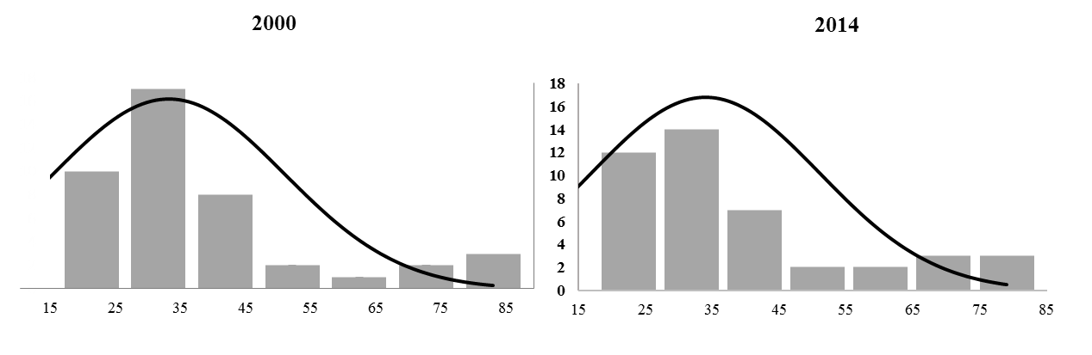
Figure IV: Total node degree distribution 2000 and 2014
Source: Author calculations based on WIOD IO data for 2000 and 2014

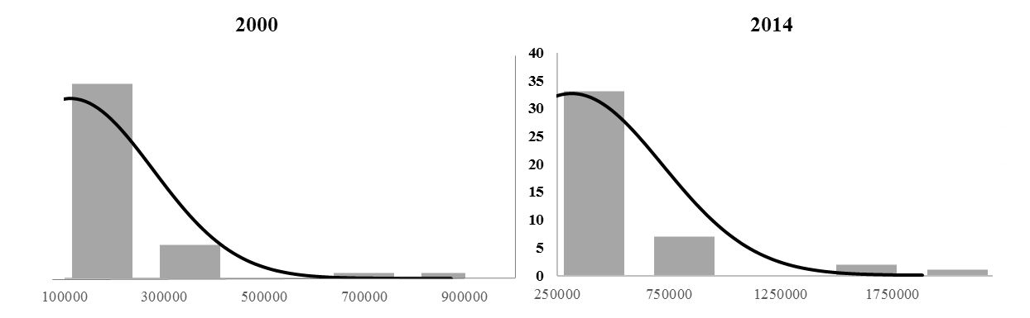

Figure V: Total node strength distribution 2000 and 2014
Source: Author calculations based on WIOD IO data for 2000 and 2014

Table II: Top 5 and Bottom 5 countries in Indegree and Outdegree Strength Percentile Rank Analysis
 | Indegree (FVA) Strenght |  | Outdegree (DVA) Strenght
 | 2000 | 2014 | 2000 | 2014
Top 5 | USA | USA | USA | USA
 | DEU | DEU | DEU | DEU
 | FRA | CHN | JPN | CHN
 | GBR | FRA | GBR | NLD
 | JPN | GBR | FRA | GBR
Bottom 5 | BGR | LTU | CYP | HRV
 | CYP | MLT | LTU | MLT
 | LTU | EST | EST | EST
 | LVA | LVA | LVA | CYP
 | EST | CYP | BGR | LVA

Source: Author calculations based on WIOD IO data for 2000 and 2014. Full percent rank analysis available in Annex 2.

An important conclusion from the percentile rank analysis in Annex 2 is that smaller countries tend to have lower positions. Table II confirms this, with the exception of Bulgaria that has noticeably moved out of the bottom five from 2000 to 2014, the same four small European countries share the bottom positions in both periods. However, the top five positions are shared between big and medium economies.
The US is the country with the highest inward and outward flows for both periods considered. Few has changed in those 15 years, with the noticeable and well documented rise of China as a supplier and user of value added in detriment to Japan which has lost its position in the top 5 countries with the highest DVA and FVA. China has entered directly to the third position in both cases, surpassing European countries as the UK and France. France actually lost in 2014 the fourth position in terms of outdegree strength to another relevant supplier of value added, the Netherlands, In Figure III it is possible to see that the arrow from this country to Germany is within the top 10 highest TiVA flows.
The distributions of Eigenvector Centrality are, once again, left-skewed, meaning that most of the countries do not hold significant supply-use relationships (Figure VI). The tendency has been constant in both periods considered, with a slight overall increase in the middle classes in 2014.

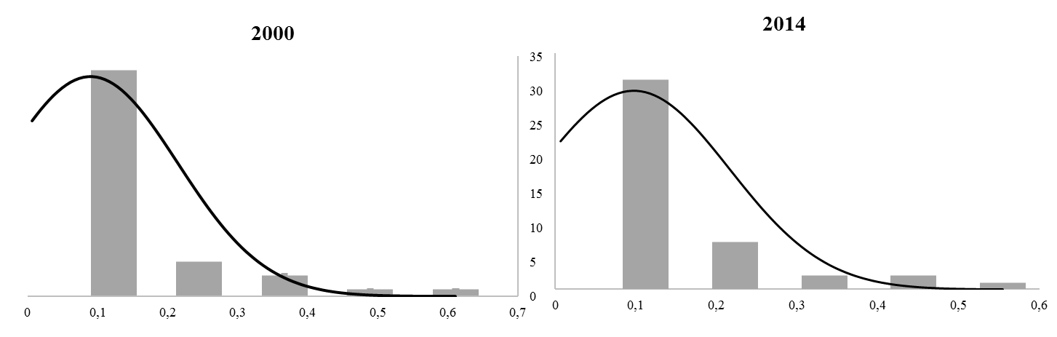
Figure VI: Eigenvector centrality distribution 2000 and 2014
Source: Author calculations based on WIOD IO data for 2000 and 2014.

Table III displays the correlation between node and eigenvector centrality. They are all positive, which means that more and more intense direct supply-use relationships contribute to a more central position within the network. An interesting aspect is that the correlation with NS is much higher than that with ND, emphasizing the character of this measure that plays down the number of partners in favour of their importance within the network. Countries such as Canada and Mexico have a low number of partners but are strongly connected to the US, which has a high centrality; therefore they also account for a high Eigenvector Centrality. The opposite occurs in countries such as Belgium and Italy, with a relatively high number of trade partners only moderately central within the network. The percentile rank analysis summed up in Table IV displays the same Top and Bottom countries as in the related Indegree and Outdegree Strength analysis.
One noticeable difference between NS percentile rank analysis and that of the Eigenvector Centrality Index is that Canada is now in the second position, due to its connection to the US. China has got the fourth position in 2014, meaning that the country is well established in the supply-use networks; however, when comparing with NS’s third position, China’s relevance is bigger when we take into consideration the intensities of the flows with its direct partners. Another significant change is the entrance of the Netherlands to the fifth position: from NS analysis, we can see that this centrality is mostly due to its upstream position in the production chain as it accounts for a higher outdegree than indegree centrality. At the same time, the strong tie with Germany also contributes to this high rank.

Table III: Correlation coefficient of centrality measures

 | 2000 | 2014
EC – NS | 0,94 | 0,92
EC – ND | 0,58 | 0,59
Source: Author calculations based on WIOD IO data for 2000 and 2014. Formula for eigenvector centrality follows Tang et al. (2015).

Table IV: Eigenvector Centrality percentile rank analysis

Percent Rank
 | 2000 | 2014
Top 5 | USA | USA
 | CAN | CAN
 | DEU | DEU
 | JPN | CHN
 | GBR | NLD
Bottom 5 | HRV | HRV
 | LVA | MLT
 | BGR | EST
 | LTU | LVA
 | EST | CYP

Source: Author calculations based on WIOD IO data for 2000 and 2014. Formula for eigenvector centrality follows Tang et al. (2015).

Nearly the same small European countries occupy the bottom positions, in parallel to the results of the NS percentile analysis. Once again, the importance of size is stressed out; furthermore, Malta’s and Cyprus’ small dimension, combined with their insular position, has an effect of increasing freight rates due to distance between main trading partners and the small size of individual shipments (World Bank, 2017).
An extended look at the full NS (Annex 2) and Eigenvector Centrality (Annex 4) percentiles’ rank allows conclusions for countries outside the top and bottom positions. Almost all emerging economies have amplified their centrality in GVCs. Indonesia and India are noteworthy evolutions; both countries are increasing their positioning as suppliers of value added. Russia has impressively increased positioning both as a supplier and importer of value added. Turkey is also gaining momentum in the international GVC scene, but still lags behind its emerging partners.

Root GVC Patterns for 2000 and 2014

To identify root or backbone patterns, a threshold that only allows the visualisation of flows above the 90th percentile was used. Figures VII and VIII represent the 10 % most robust flows of the world’s user and supplier’s network for 2000 and 2014, respectively.
Comparing both networks, one sees that in 2014 there is a greater number of relevant flows, as well as more countries. Russia, India, Luxembourg, Czech Republic and Brazil enter this more restricted trade scene, while Indonesia has lost relative importance as a supplier of intermediates to Japan, and Sweden as a consumer of German intermediates.
In both periods, most of the flows above the threshold are bilateral ones between a country and its partner. Geography also plays a role: in 2000, 38% of the most relevant flows were between countries that share territorial borders; in 2014 this increased to more than 40%.
The analysis can be enriched by aggregating nodes and flows in the world’s big production regions, Factories Asia, Europe and North America. Figures IX and X indicate that most of the global production activities still take place within regions, as seen from the width of the regional self-loops. This is nevertheless slightly decreasing in all regions but Asia, where the share of intra-regional trade in value added has gone from 34% to 36%.
Noticeably, the share of Asian TTVA with North America has lost relative importance, from 38% to 26%. Various factors can help explain this: not only intra-Asian TTVA has increased but also Asia (mostly China) has deepened its ties with Europe and emerging economies as Russia and Brazil.
The figures also show a decrease in the share of European TTVA with North America. The importance of intra-European trade in intermediates is more evident than in the other two regions. In fact, the share of the European TTVA is well above 60% in both periods and it has only slightly decreased from 66% to 65%.
Western European countries are mostly suppliers of value added to their European counterparts. From 2000 to 2014, only the UK has switched from a net supplier to a net user of value added for the countries that integrate the 10% most relevant flows. The country holds a steady trade link with Norway, mostly due to its imports of primary commodities. Ireland and Luxembourg are importers of value added from the UK, mainly services, what is consistent with the positioning of Luxembourg as a financial centre and Ireland as a location for headquarters of multinational corporations. Ireland also maintains a strong tie with the US. France remains essentially European in its production networks, with a somewhat robust input link with North America.
Germany, as previously stated, remains at the core of Factory Europe, and holds the most relevant inter-regional production relations with the US and China, being, in both cases, a net supplier of value-added. It is also responsible for the presence of Poland in the 10% most relevant flows in 2000 and 2014, as well as the Czech Republic’s emergence in 2014. These countries’ main trade with Germany is in supplying medium-technology intermediates to the chemical and automotive industries. According to the World Bank’s 2017 GVC report, each of them specializes in different tasks along the automotive production chain; Czech industries in medium-low technology inputs and Polish in medium-high ones. Germany maintained important supply and use relationships with bordering European countries such as Switzerland, besides those with Austria, Belgium and mostly with the Netherlands, one of its net suppliers.
Russia has emerged in the global production scene at the upstream margin of GVC, something typical for countries that specialize in primary commodities. The country’s most valuable exports go to China and Germany, the latter also an important supplier of value added to Russia.
Factory Asia has not only been intensifying its internal production links as experiencing rapid transformation, with China seemingly adopting the model of its Asian neighbours that have entered the GVCs in the final stages of the manufacturing process. South Korea, a former major player in Japanese production chains, is now home to multinationals in the field of electronics (Samsung, LG) and in the automotive sector (KIA, Hyundai). It still holds large TiVA links with Japan but has evolved as a crucial supplier of and user of China’s inputs. This model is the core of intra-Asian production chains and helps explaining why China has become a supplier of value added to India.
In 2014, 9% of Asia’s TTVA was with Australia, a country profoundly integrated in the Asian production processes. In 2000, it was already an important supplier of production inputs to Japan; in 2014, the link is still strong but the new one with China has surpassed it.
The most relevant ties within NAFTA are centred around the US. Mexico is gradually increasing its role as a supplier of value added to the US, especially in the automotive sector. In recent years, it has supplanted Canada as the main provider of automotive components to the US (World Bank, 2017).
Notwithstanding Brazil’s still modest participation in the global production networks -it mostly trades with its MERCOSUL neighbours-, the country has entered the world’s most robust flows in 2014 as a net exporter of value added to China and a net importer from the US; a situation that conditions its production possibilities.

Figure VII – 2000 world’s supplier and user network cut by the 10% highest flows. Pink nodes represent net importers of intermediates and blue nodes represent net exporters of intermediates to the countries included in this threshold.

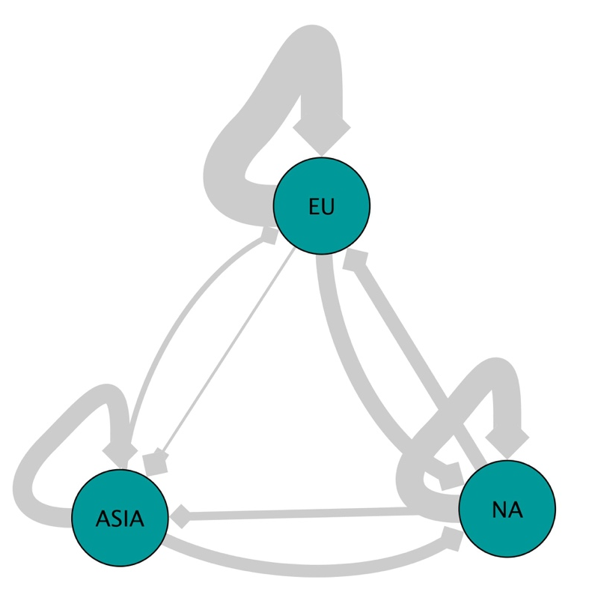
Figure VIII – 2014 world’s supplier and user network cut by the 10% highest flows. Pink nodes represent net importers of intermediates and blue nodes represent net exporters of intermediates to the countries included in this threshold.

Figure IX – 2000 world’s supplier and user regional network. Asia include China, South Korea, Japan, India, Indonesia and Taiwan; Europe included all 27 EU countries, plus Switzerland and Norway. NA corresponds to all 3 NAFTA countries.
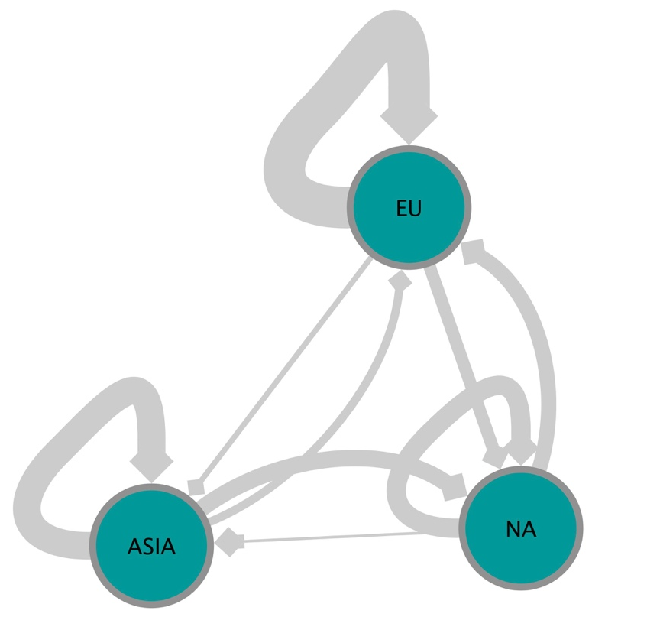

Figure X – 2000 world’s supplier and user regional network. Asia include China, South Korea, Japan, India, Indonesia and Taiwan; Europe included all 27 EU countries, plus Switzerland and Norway. NA corresponds to all 3 NAFTA countries.

6. Conclusions.

The present work provided an empirical contribution to the network analysis of the world web of suppliers and users of value added. It belongs to a line of studies that represent IO matrices as weighted and directed networks, displaying the different values of supply-use flows among countries or countries-sectors.
From 2000 to 2014, the world’s trade in value added has more than trebled and its geographical spread has become less unequal, with more countries and bilateral flows relevant for the GVCs. Countries with a greater number of partners also account for higher values of trade in value added; major suppliers tend to be major users also.
However, most of the countries do not hold meaningful trade relationships or a significant number of partners and their total trade in value added is still small. Thus, the distribution of all centralities parameters is left-skewed.
When one takes into consideration the importance of partners instead of the value of trade, the centralities that emerge highlight the role of shared borders and trade agreements, such as with Canada, Mexico and the US, or Netherlands with Germany.
Notwithstanding patterns in the global production networks show a strong regional dimension and that geographic borders play an important role, it is hard to conceive the GVCs phenomenon without the initial contracting out trend in the US and the steady industrial capacity of Germany. The networks associated to the two time-frames here analysed clearly support this, as well as how crucial Asia was, with its virtuous dynamics, combining the evolving roles of Japan, South Korea and China (besides less important players, like Vietnam and Thailand, not included in the WIOD).
The GVCs phenomenon remains however, as implied by the distribution of the several centrality measures, highly asymmetric, despite a certain diversification of world production centres.
Is the model possible without strong regional hubs enjoying the possibility of linkages to other major markets?
We venture that with only a strictly regional market, or a fully globalised one, GVCs may be unfeasible or, at least, less frequent. The regional hub property provides a basis for a process of continuous outsourcing and supply that feeds the growth and upgrading of the centre, while the linkages to other major markets add needed more consumers to keep and ever-increase scale gains, besides multiplying the fragmentation options.
But, at the end of the day, concentration seems to be the name of the game. Without Germany, Factory Europe loses its pumping engine; the same for Asia without China and, in 2014, for the whole world, without the US.
Emerging countries have intensified their positioning in the world trade network from 2000 to 2014, driven by upping the intensity of previous relationships with the key hubs. Will China eventually either absorb or dominate the other hubs, becoming the new central node of the WTN?

References

Amador, J., & Cabral, S. (2015). A basic network perspective. Em J. Amador, & F. d. Mauro, The Age of Global Value Chains: Maps and Policy Issues (pp. 58-67). London: Centre for Economic Policy Research.

Aslam, A., Novta, N., & Rodrigues-Bastos, F. (2017). Calculating Trade in Value Added. IMF Working Paper, 1-25.

Baldwin, J., & Yan, B. (2014). Global Value Chains and the Productivity of Canadian Firms. Economic Analysis (EA) Research Paper Series , 1-29.

Benedictis, L. D., & Tajoli, L. (2011). The World Trade Network. The World Economy, 1417-1454.

Bhattarcharya, K., Mukherjee, G., Saramaki, J., Kaski, K., & Manna, S. S. (2008). The International Trade Network: weighted network analysis and modelling. Journal of Statistical Mechanics: Theory and Experiment, 1-10.

Blochl, F., Theis, F. J., Vega-Redondo, F., & Fisher, E. O. (2011). Vertex Centralities in Input-Ouput Networks Reveal the Structure of Modern Economies. Physical Review E, 1-8.

Bonacich, P. (1987). Power and Centrality: A Family of Measures. AJS, 1170-1182.

Brach, J., & Kappel, R. T. (2009). Global Value Chains, Technology Transfer and Local Firm Upgrading in Non-OECD Countries. GIGA Working Paper , 1-26.

Carvalho, V. M. (2014). From Micro to Macro via Production Networks. Journal of Economic Perspectives, 23-48.

Cerina, F., Zhu, Z., Chessa, A., & Riccarboni, M. (2015). World Input-Ouput Network. PLoS ONE, 1-21.

Contreras, M. G., & Fagiolo, G. (2014). Propagation of Economic Shocks in Input-Ouput Networks: A Cross-Country Analysis. LEM Working Paper Series, 1-20.

Criscuolo, C., & Timmis, J. (2018). GVCs and Centrality: Mapping Key Hubs, Spokes and the Periphery. Paris: OECD.

Fagiolo, G., Reyes, J., & Schiavo, S. (2008). On the topological properties of the world trade web: A weighted network analysis. Physica A, 3868–3873.

Garlaschelli, D., & Loffredo, M. L. (2005). Structure and evolution of the world trade network. Phisica A, 138–144.

Hummels, D., Ishii, J., & Yi, K.-M. (2001). The nature and growth of vertical specialization in world trade. Journal of International Economics, 75-96.

Kali, R., & Reyes, J. (2007). The architecture of globalization: a network approach to international economic integration. Journal of International Business Studies, 595-620.

Kim, S., & Shin, E.-H. (2002). A Longitudinal Analysis of Globalization and Regionalization in International Trade: A Social Network Approach. Social Forces, 445-468.

Koopman, R., Powers, W., Wang, Z., & Wei, S.-J. (2011). Give credit where credit is due: Tracing value added in global production chains. NBER Working Paper Series. Cambridge, MA: National Bureau of Economic Research.

Koopman, R., Wang, Z., & Wei, S.-J. (2014). Tracing value added and double counting in gross exports. American Economic Review, 104(2), 459-494.

Mahutga, M. C. (2006). The Persistence of Structural Inequality? A Network Analysis of International Trade. Social Forces, 84, 1863-1889.

Martinez-Galán, E., & Fontoura, M. P. (2018). Global value chains and inward foreign direct investment in the 2000s. World Economy, 1-22.

Reyes, J., Garcia, M., & Lattimore, R. (2008). The International Economic Order and Trade Architecture. Globalisation and Emerging Economies , 13-31. OECD Publications.

Sabidussi, G. (1966). The Centrality Index of a Graph. Psychometrika, 581-603.

Saliola, F., & Zanfei, A. (2009). Multinational firms, global value chains and the organization of knowledge transfer. Research Policy, 369–381.

Santoni, G., & Taglioni, D. (2015). Networks and structural integration in global value chains. Em J. Amador, & F. d. Mauro, The Age of Global Value Chains: Maps and Policy Issues (pp. 68-84). London: Centre for Economic Policy Research.

Serrano, M. Á., & Boguñá, M. (2003). Topology of the world trade web. Physical Review, 1-4.

Serrano, M. Á., Bogunã, M., & Vespigani, A. (2007). Patterns of dominant flows in the world trade web. Journal of Economic Interaction and Coordination, 111-124.

Smith, D. A., & White, D. R. (1992). Structure and Dynamics of the Global Economy: Network Analysis of International Trade 1965–1980. Social Forces, 857-893.

Snyder, D., & Kick, E. L. (1979). Structural Position in the World System and Economic Growth, 1955-1970: A Multiple-Network Analysis of Transnational Interactions. American Journal of Sociology, 1096-1126.

Taglioni, D., & Winkler, D. (2016). Making Global Chains Work for Development . World Bank Group.

Tang, Y., Li, M., Wang, J., & Wu, F.-X. (2015). CytoNCA: A cytoscape plugin for centrality analysis and evaluation of protein interaction networks. ByoSystems, 67-72.

World Bank. (2017) Measuring and analyzing the impact of GVCs on economic development(English). Washington, D.C. : World Bank Group.

